# INTRODUCTION

## System Introduction

This document describes the requirements and specifications of Online Auction System. This document is intended to explain the functional features of the website along with interface details and design constraints. This will help us to clearall the issues between client and developers.

## Background of the System

## Before we analyze the design of the proposed system, we need to carefully highlight the problems of the existing system to avoid recurrence. This analysis serves as a pointer on how to embark on building the proposed system that will help the online auction stores to provide optimal inventory management by monitoring orders. Customers must go with big hassle like elder people have difficulty traveling, disabled people face big problems to even reach at auction ceremonies, women face privacy issues, unavailability of desire products leading to more hassle. So, providing a platform where each customer can go for auction anytime and anywhere is a big solution for all mentioned problems. Our system also provides multiple products or items so the customer is looking for can be found at our online auction store without leaving the website.

## Objectives of the System

* The main aim is to develop an online auction system which will provide a forum for sellers to meet and interact with buyers and sell items to interested bidders.
* Create an online forum where bidders auction for items posted by the seller through the online system.
* Create a panel whereby a seller receives requests from a buyer and sends back feedback, an answer to a question or requests to meet the bidder.
* In addition, to implement and test the work-ability of the newly developed system. It will include different processes like database creation, website creation, documentation, architectural design, testing etc.

## Significance of the System

* + - User friendly interface.
    - Interactive
    - Serviceable
    - Organized

# REQUIREMENT SPECIFICATIONS

## Product Scope

This system is designed as an online web-based application which shall be accessed by any device, either a computer, tablet, iPad, iPhone, mobile phone or PDAs. System is targeted to serve primarily my local town, then by more modification it shall serve the whole country where more business enterprises shall have access to the system. The scope of this application to build a user-friendly auctioning website, where user will be able to auction any product which is available nearby or anywhere in the town. By using Online Auction management system, it will be easy for auctioneer to make an auction and time saving also. By making auction through this application will help to reach maximum of buyers bidding in local area. There will be a feature where bidder and seller can message each other.

## Product Description

### Product Perspective

### The product is a web-based system implementing client-server model. The following are the main features:

### Cross platform support – it offers operation support for most of the known and commercial operating systems including windows operating system, X operating system, Linux operating system, android operating system, chrome operating system etc.

### Admin Accounts- this system will allow admin dashboard for more control on user’s accounts.

### User accounts – this system allows the system users to create system accounts, view and update their profiles.

### Users supported in the system – the system support quite users at one time.

### Search – it is a local search engine based on finding key words.

### Chat platform – the system allows the users and the seller of products to chat through an inbuilt chat platform feature.

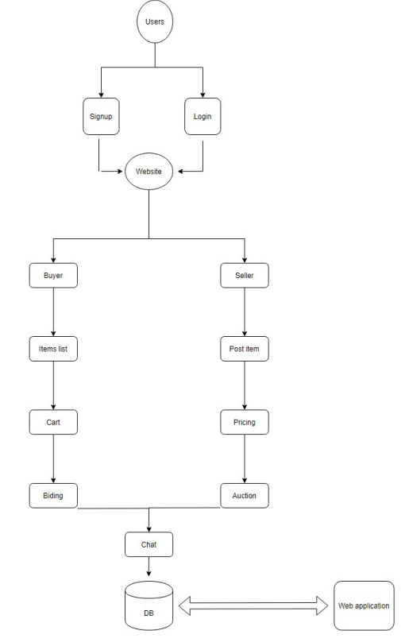

### Product Functionality

### Enable the users to view posted products in their locality and proximity

### Enable creation of accounts and logging in to the accounts

### Enable users to logout of their accounts

### Provide interface for the administrator to view the transactions, add sellers and regions to the system.

### The sellers should also have accounts where they will receive the customer orders and respond to them.

### Users and Characteristics

### The system requires that the users be equipped with overall internet knowledge and the gadget accessing it. The administrator is expected to have more skills with the interface of the tech support system. The sellers should also have skills of well analyzing and navigating the internet usage and be able to handle customers who may not be so familiar with the internet.

### Operating Environment

## The system highly relies on browsers that support HTML5 sites, the users with older versions of browsers of incompatible ones will need to upgrade to the newer browser versions.

## Specific Requirements

### Functional Requirements

### Functional requirements for the online auction management system have been developed to make sure that the functionalities and functional aspects of the system are met.

### **Login:**

### System will allow the user to login.

### System will verify the username and password.

### System will not allow user to login with invalid username or password.

### System will be able to remember username and password.

### **Registration or create account:**

### System will allow users to create account.

### **Browsing and database search:**

### System will allow user to search products that are available for auction.

### System shall display the result.

### System will allow the bidder to bid on desired product.

### **My Auction:**

### System will allow users to post the ad for product they want to sell.

### System will allow users view their active bids (that are in progress).

### System will allow user to view their expired bids.

### **Purchase History:**

### System will allow the user to view their purchase history.

#### Bidder/Seller Login

### The users with the user type as bidder or seller will be able to log in to the system.

#### User Registration

### In case of the absence of the user id and password, the user will be able to register themselves in the system. The user interface and the source code for this requirement must be finished. This will allow a user to register with the online auction management system.

#### Browsing & Database Search

### The database will include the products that are available for auction and the user will be able to see the products browsing through the database. The admin may also search for a user using the search option. This will allow the users to search results based on the keyword entered.

#### Chat Option

### The bidder and seller will be given the ability to chat with each other regarding a specific product. The source code and user interface for the functionality have been done while the unit testing and other testing activities are pending. This will allow the bidder and seller to connect with each other.

#### Sell Product Progress

### The user can use this option to post the advertisement on the website for a particular product that is to be sold. The details of the product will be put into the template provided for the advertisement. The UI aspects for the functionality have been created while the source code and conduction of testing activities are pending. This will allow the user to post and advertisement on the website for selling the product.

#### Application Maintenance Progress

### The installation of the updates and patches along with the maintenance of the website. To allow the admin to install updates and patches for the site and maintain the quality of the website.

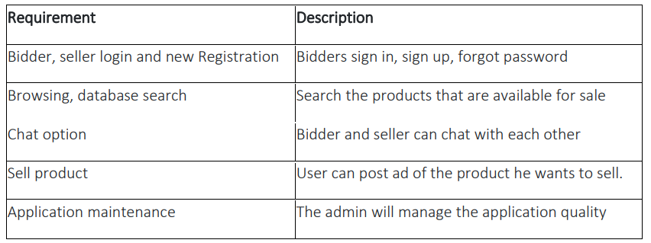

### Behavioral Requirements

The application requires no special technical guidance and all the views available in the application are self explanatory. The users are well guided with warning and failure messages for all the actions taken.

It is extremely significant to understand the needs of the user in a project. Use case diagram assists in defining the user requirements and needs. It also shows the interaction between the system users and the system itself which allows easier designing and development activities. The users for online auction management web site will be bidder, seller, or admin. They will perform the various activities as illustrated in the functional requirements section.

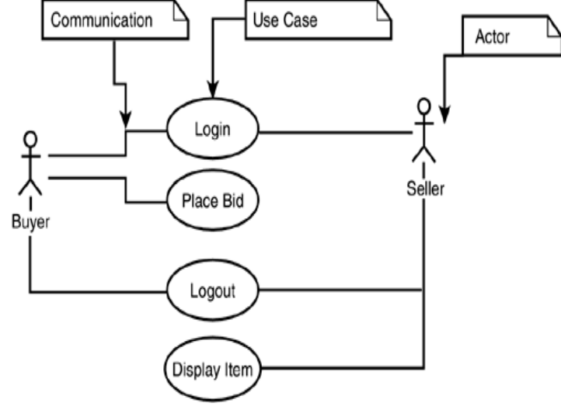

### External Interface Requirements

* The application ought to be web based.
* System feature should be improved for better execution

#### User Interface

#### Other Interfaces (if any)

**Hardware Interfaces**

No hardware is included in the project.

**Software Interfaces**

* Windows/ android/ Linux/ mac/ chrome or any other operating system.
* Mozilla Firefox / Google chrome / opera mini / UC browser or internet explorer.

**Communication Interfaces**

Internet connectivity: User must have a active internet connection.

## Non-functional Requirements

<*If anything out of the followings*>

### Performance Requirements

* The website for online auction management system shall have the following abilities and capabilities.
* The responsiveness of the website shall be high, and the website shall behave as per the user action.
* The user shall be acknowledged in the form of visual changes or feedback on the site to enhance the interaction.
* The response time and throughput time on the site shall be minimal.
* Consistency on the website shall be maintained across all the web pages.
* The layout of the site shall be kept simple and must be self-explanatory.

### Safety and Security Requirements

* The auction shall be running in real time. This means that clients always have current information visible. This is important for short time auctions, where the frequency of bids is relatively high.
* An auction may consist of several slots, allowing the buyers to split the material desired among several suppliers. This allows to prevent a dependency on a single supplier only, as well as to split delivery.

### Software Quality Attributes

The web site shall always provide the users with valid information.The response rate of the website will be very fast. The website is very organized and structured. We have used a very easy-to-understand interface so that our users can easily navigate through the website without any difficulty.

# DESIGN SPECIFICATIONS

<*It is highly recommended that you write brief summary of every chapter as a preamble explaining what a reader would find in this chapter. Thus, when a reader reads summary of your chapter at the beginning, the forthcoming contents shall become clear.*>

## Introduction

This software system, an Online Auction System is developed for allowing our users to buy and sell things. The main purpose of the website is that all the items that a person wants to sell will be added in the database, which will be automatically removed after the item is sold to someone. It will be helpful for the seller in getting a good bid on their item and the buyer can get the item they are looking for without the hassle of going and searching the market for the item. The items will be reviewed by the admin before posting it on the website. The bidding will automatically close without updating the buyers for fair auction of the system. The system will help maximize the time and resources.

## Composite Viewpoint

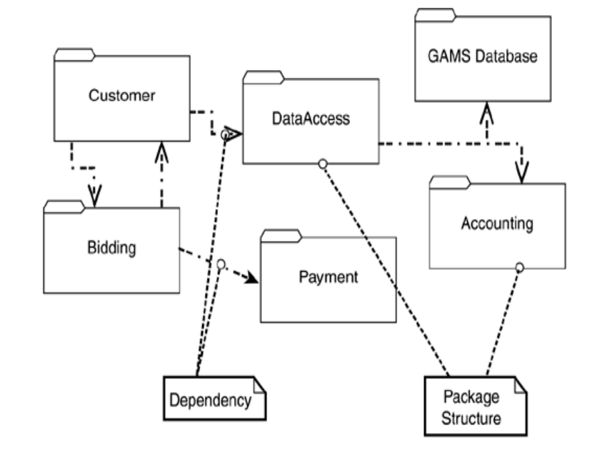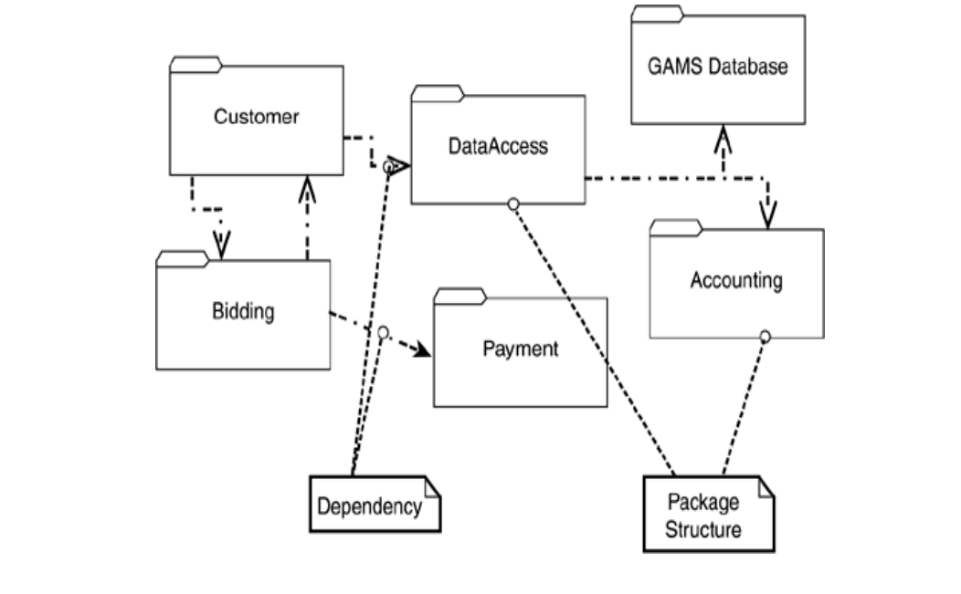

## Logical Viewpoint

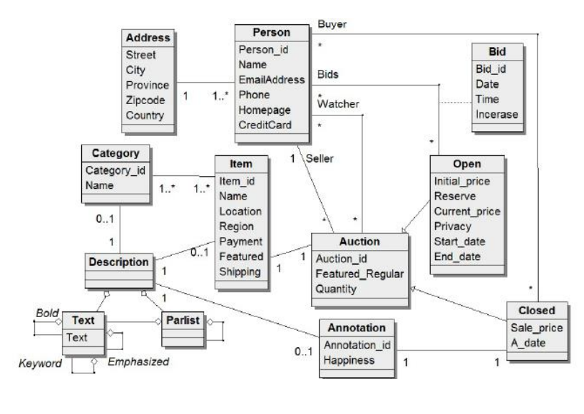

## Information Viewpoint

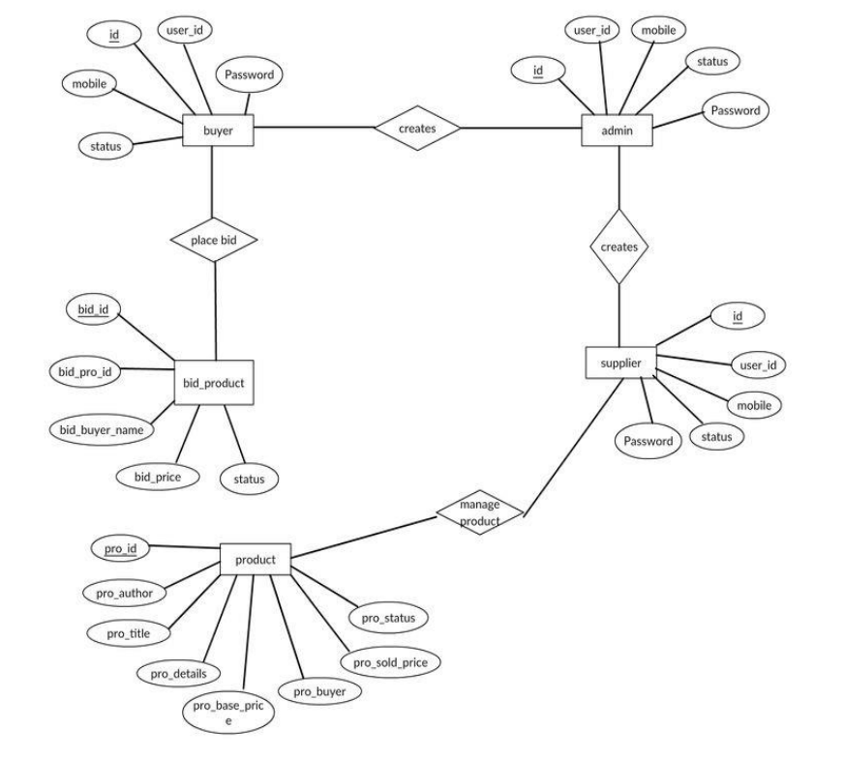

## Interaction Viewpoint

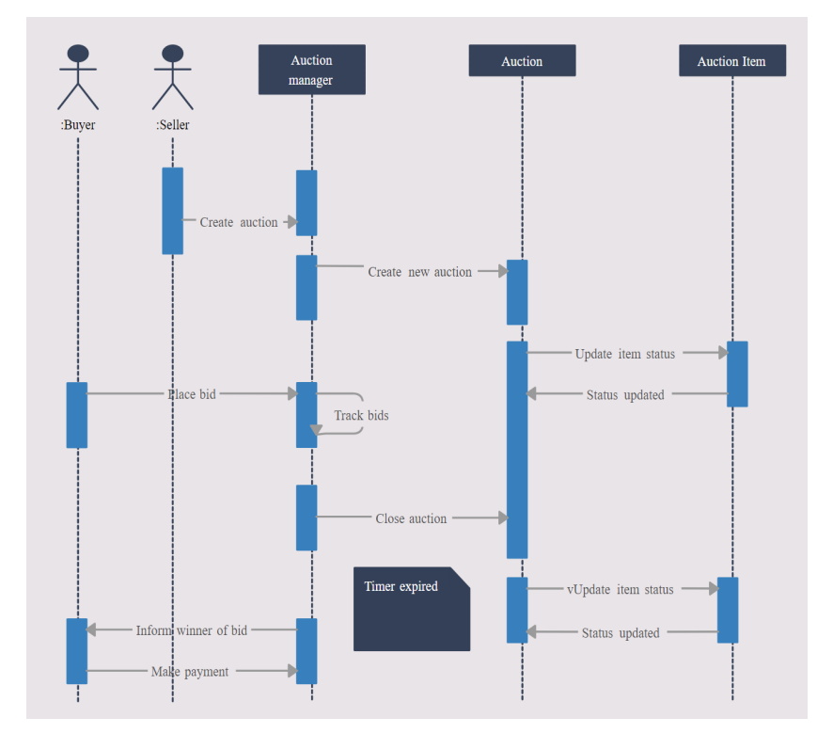

## State Dynamics Viewpoint

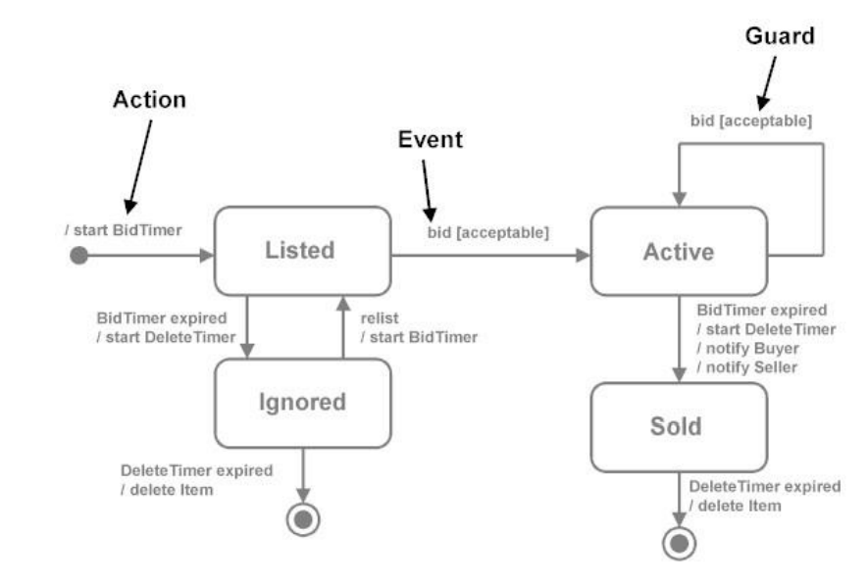

## Algorithmic Viewpoint

Pseudo Code for Auction System:

start {Set auction clock to its starting value}

{Currently there is no winner}

{Start the current offer at 0}

t=bidding time while

t > 0 do

for all Bidders do

if BidButton then

{the current highest bidder}

{Charge the bid cost}

{Increment the offer}

t ={Stop the auction clock randomly after 36 hours}

{highest bidder wins item}

{Winner pays item price}

# DEVELOPMENT AND TOOLS

## Introduction

The software is developed using Microsoft Visual Studio Code using Laravel php Framework. MySQL database with XAMPP Application. Moreover, the website contains Bootstrap, PHP, JavaScript, HTML/CSS & Laravel’s Blade code.

## Development Plan

One of the main components of this system is the creation of a website that is helpful for users of any age to reach the greatest number of users. Another important component is the widespread use of the Online Payment System for quick and efficient transactions.

## Development Tools

## Microsoft Visual Studio Code

## Laravel Framework v8

## mySQL

## HTML/CSS

## XAMPP

## Conclusion and Future Work/Extensions

We are thankful to ALLAH ALMIGHTY who has given us the courage to fulfill our task. This projection is quite enjoyable as we have been given the opportunity to manage a project from start to finish. It was due to this project that we came to know how a professional software is designed.

We have worked on everything we have proposed in the proposal to make an efficient and better website which will help the buyer and seller to easily auction their items and it will help the buyer to search and bid on the item they are looking for in hassle free manner.

# QUALITY ASSURANCE

<*It is highly recommended that you write brief summary of every chapter as a preamble explaining what a reader would find in this chapter. Thus, when a reader reads summary of your chapter at the beginning, the forthcoming contents shall become clear.*>

## Introduction

<*Briefly describe what this chapter includes*.

TO DO: One paragraph of consisting of 3-5 lines>

EXAMPLE:

In quality assurance phase which is mainly based on Test plan including testing strategies and types of testing applied to ensure the reliability and accuracy of the application to give the user a great and error free learning experience. Since satisfaction of end user is a first and foremost priority, thus to ensure it, a proper testing mechanism was devised and the results are tabulated in the form of test cases and to trace each test case against desired functional requirement a requirement traceability matrix have been devised which include test case ID against each and every functional requirement desired by user.

## Traceability Matrix

< *The requirement traceability matrix for each test case against functional requirement is to be provided in this section.*

TO DO: Traceability Matrix as per format given below>

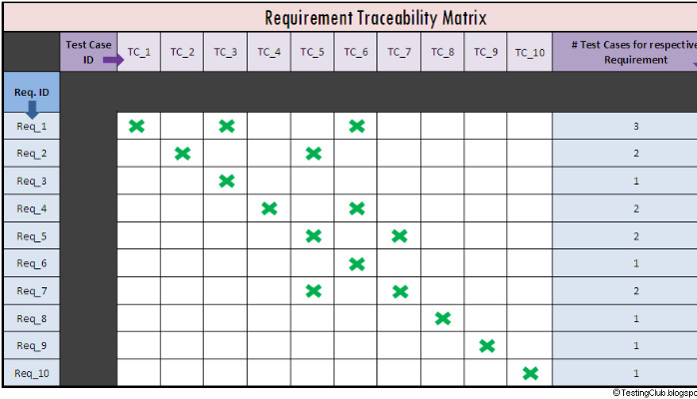

## Test Plan

< *Test plan contains the testing mechanism and the entire tests that have been conducted to test the application. This section should include all the test cases conducted for quality assurance of each function requirement.*

TO DO: Heading of each functional requirement and test case in tabulated form as shown in the example below. This table should be repeated for every test case>

EXAMPLE:

Table 5.1: Test case for Application start up

|  |  |
| --- | --- |
| **Test ID** | **ABC-1** |
| **Test name** | Application start up |
| **Date of test** | 10/11/2013 |
| **Name of application** | Kids’ Android Teacher |
| **Description** | Home screen will be displayed where user will select learning of Urdu or English alphabet letters or view progress record or exit application. |
| **Input** | Tap on the application icon |
| **Expected output** | Home screen displayed |
| **Actual output** | Home screen displayed |
| **Test Role (Actor)** | Team Member |
| **Test verified by** | Team Member/Supervisor |

# USER MANUAL

<*It is highly recommended that you write brief summary of every chapter as a preamble explaining what a reader would find in this chapter. Thus, when a reader reads summary of your chapter at the beginning, the forthcoming contents shall become clear.*>

## Introduction

<*Briefly describe what this chapter includes.*

TO DO: One paragraph of consisting of 3-5 lines>

## Hardware/Software Requirements for the System

<*Specify all Software/Hardware requirements for installation and execution of the application.*

TO DO: List down all requirements in bullet/tabulated form>

## Installation guide for Application

<*This section should include comprehensive guidelines for installation procedure.*

TO DO: Specify all steps in bullet form along with screenshots.>

## Operating Manual

<*This section should include comprehensive guidelines to operate the application.*

TO DO: Specify a complete operating manual to access all functionalities of the application. It should include screenshots of application.>